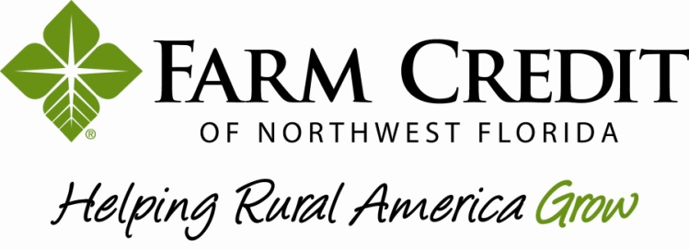

Is pleased to announce results of the
2021 Board of Directors Election
___________________________________________

Board of Directors
Region One
Jacob Gilmore

Region Two
David Yoder

Region Three
R. Douglas Walker
______________________________

2022 Nominating Committee Election Results
Region One
Jacob Tyler Brown
Sheldon Flinn
Lucas Killam (Alternate)

Region Two
Cindy Jordan
R. Allen Scheffer
Joshua B. Davis (Alternate)

Region Three
Joshua Churchwell
Jeffery W. Hamrick, Jr.
M. Kate Clark (Alternate)

Congratulations to the winners from each region!

